ECS189G Computer Vision Problem Set 0

WEI-CHIH CHEN

ID: 912448776

1. Using Matlab
2. (Skip)
3. a. >> x = randperm(1000);

**ANS**: x is a 1x1000 array with 1000 random values which values are from 1 to 1000.

b. >> a = [1,2,3; 4 5 6; 7 8 9];

>> b = a(2,:);

**ANS**: a is a 3x3 matrix and b is a 1x3 array which values are the second row of a.

c. >> a = [1,2,3; 4 5 6; 7 8 9];

>> b = a(:);

**ANS**: b is a 9x1 array which values are rows of ‘a’ that concatenate row by row.

d. >> f = randn(5,1);

>> g = f(find(f > 0));

**ANS**: f is a 5x1 array with normally distributed random number. And g is an array with positive values of f variable.

e. >> x = zeros(1,10)+0.5;

>> y = 0.5.*ones(1,length(x));

>> z = x + y;

**ANS**: x and y are 1x10 array with 0.5 of every elements. z is an addition of these two array so z is a 1x10 array with 1 of every elements. The different of x and y is the way to define array.

f. >> a = [1:100];

>> b = a([end:-1:1]);

**ANS**: a is a 1x100 array with every element increasing 1 from 1 to 100. And b is a 1x100 array with every element decreasing 1 from 100 to 1.

1. a. Use rand to write a function that returns the roll of a six-sided die.

**ANS:** function y =die()

r=randperm(6);

y=r(1);

end

b. Use the reshape command to form a new matrix Z

**ANS**: z = reshape(y,2,3)

c. Use the max and find functions to set x to the maximum value that occurs in Z (above), and set r to the row it occurs in and c to the column it occurs in.

**ANS**: [r,c]=find(z==max(max(z))) % find the max value in array z; max(max(x)) is the max value in z.

% find function can return that value by row and column.

d. Let v be the vector: v = [1 8 8 2 1 3 9 8]. Set a new variable x to be the number of 1’s in the vector v.  
**ANS**: x=length(find(v==1)) % find 1’s in the vector v and count the number.

1. a. **ANS**:

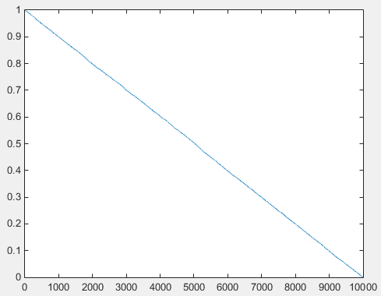

b. **ANS**: h=histogram(B,20)

% http://www.mathworks.com/help/matlab/ref/histogram.html?searchHighlight=histogram

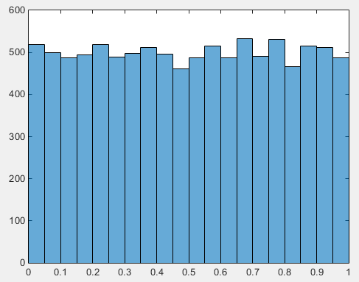

c. **ANS:** Z=A(51:100,1:50); imshow(Z)



d. **ANS**: W=A-mean2(A); imshow(W)

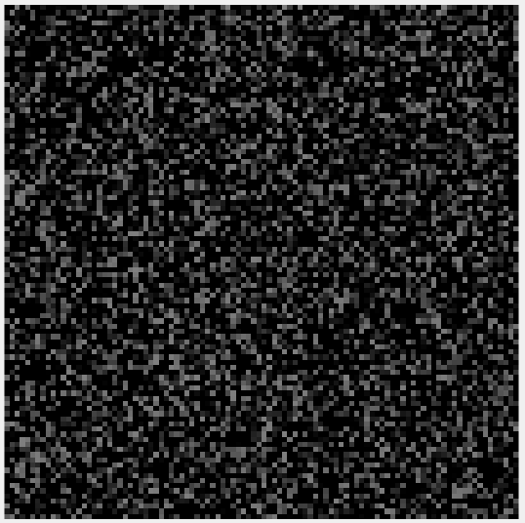

e. **ANS**:   
Y=zeros(100,100,3); %initial RGB image with zero

I=find(A>= mean2(A));

Y(I)=255;

Y(:,:,2)=Y(:,:,1);

Y(:,:,1)=Y(:,:,3);

figure

imagesc(Y)

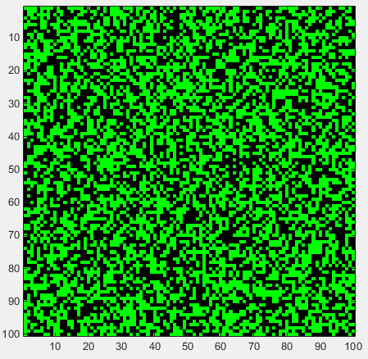

1. Short programming example

**ANS**: (Next Page)

